**Assignment: GroupSms Part 3**

**Author: Alessandro Ferro**

**TESTING DOCUMENT**

1. **Method ButtonAddNewOnClickHandler**

1.1 Code

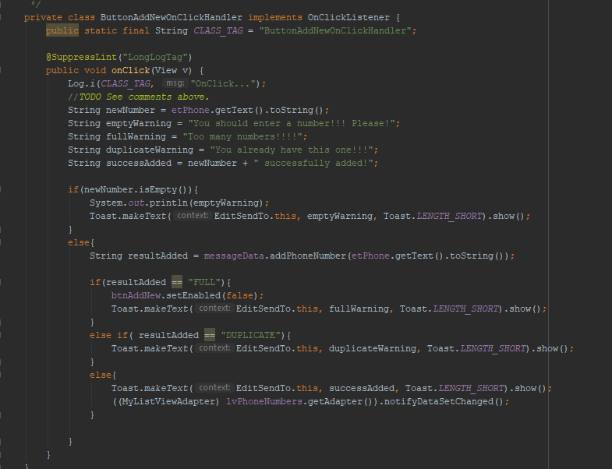

This method allows the user to add additional phone numbers to send a message to.

The method is expected to update the view once the number is added.

The main activity should also be updated to display the numbers added by the user.

The method keeps in consideration the possibility of the array being full and the user trying to add a duplicate number and output appropriate Toast messages to the screen in each case.

If it’s full the ‘Add New’ button is disabled.

A Toast message is output to the screen in case of success.

1.2 The method in action

|  |  |  |
| --- | --- | --- |
| Figure : EditSendTo Activity - Before Adding ‘2222222222’ | Line arrow: Straight | Figure : After adding ‘2222222222’ |

* 1. Upon pressing the ‘DONE’ button, the app return to the Main Activity.

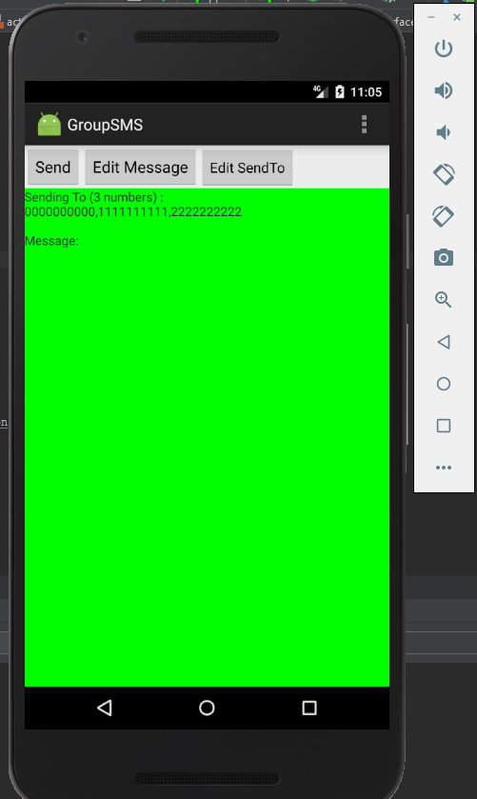

Figure : Number added in main activity

1. **Method ButtonDeleteOnClickHandler**

2.1The Code

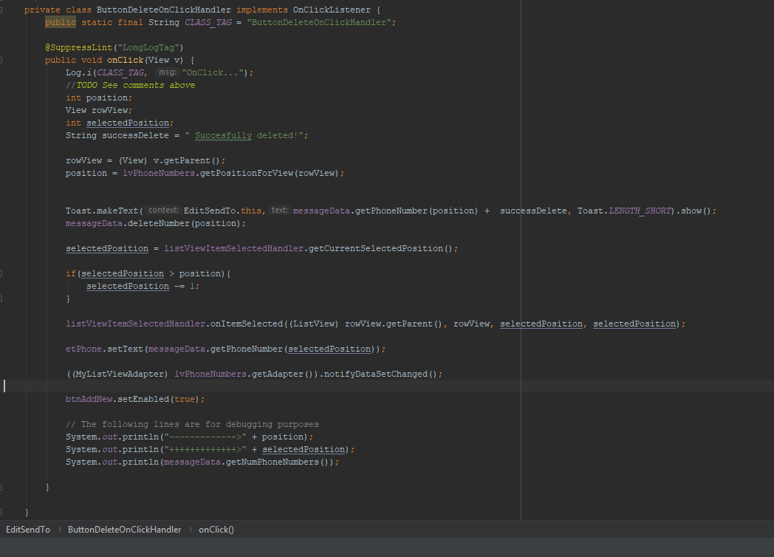

This method allows the user to delete numbers that have been previously added (default numbers included).

The method allows the user to select any number and delete any number independently. The number being selected shouldn’t affect which number is deleted.

The method handles the behaviour of the selected numbers in the ListView consistently.

The main activity gets updated upon deletion.

The ‘Add New’ button is enabled.

A Toast message is output to the screen to further notify the user of the operation completed.

2.2 Starting Screen – Four numbers in the array

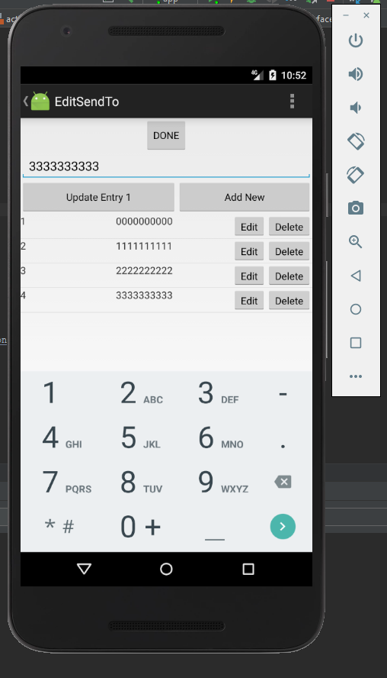

Figure : Added '2222222222' and '3333333333'

2.3 First Case: Select third number and delete the first number.

|  |  |  |
| --- | --- | --- |
| Figure : Third number selected | Line arrow: Straight | Figure : First number deleted |

2.4 Second Case: Select third number and delete last number

|  |  |  |
| --- | --- | --- |
| Figure : Select third number | Line arrow: Straight | Figure : Delete fourth number |

2.5 Third Case: Select third number and delete third number.

|  |  |  |
| --- | --- | --- |
| Figure : Select third number | Line arrow: Straight | Figure : Delete third number |

1. **Stepping through the code**

3.1 Starting point – Added ‘2222222222’ 🡪 Delete ‘0000000000’

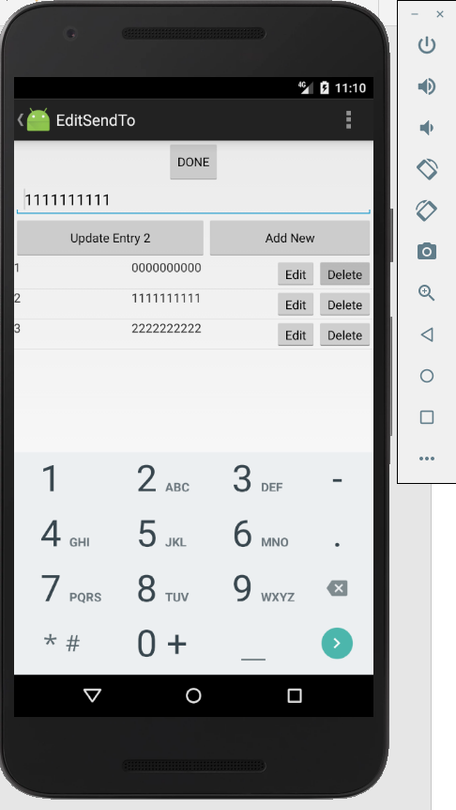

Figure : Added '2222222222'

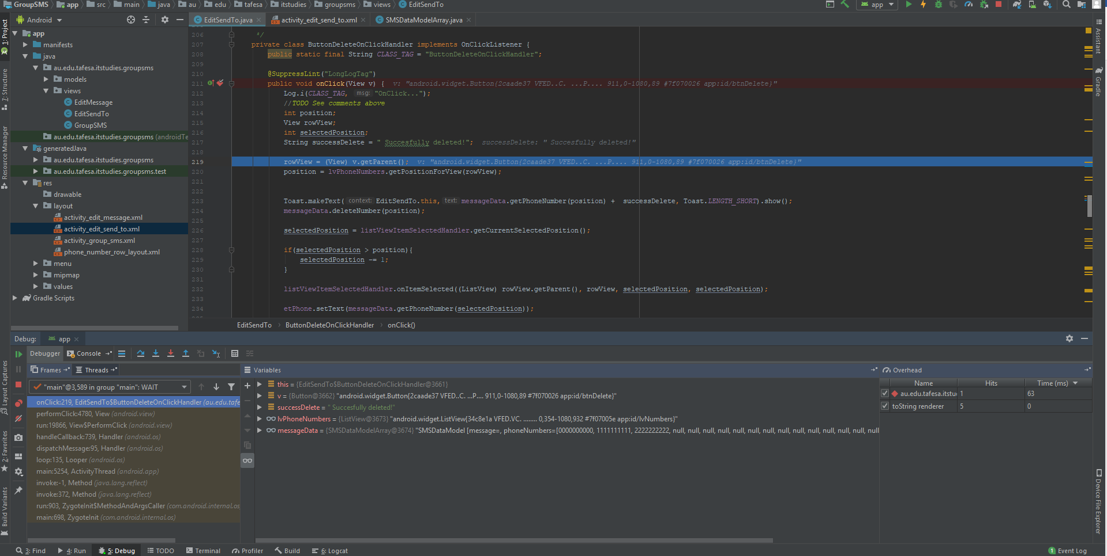

Figure : Break point at the beginning of the method

* 1. Steps through the method



Figure : Get the View



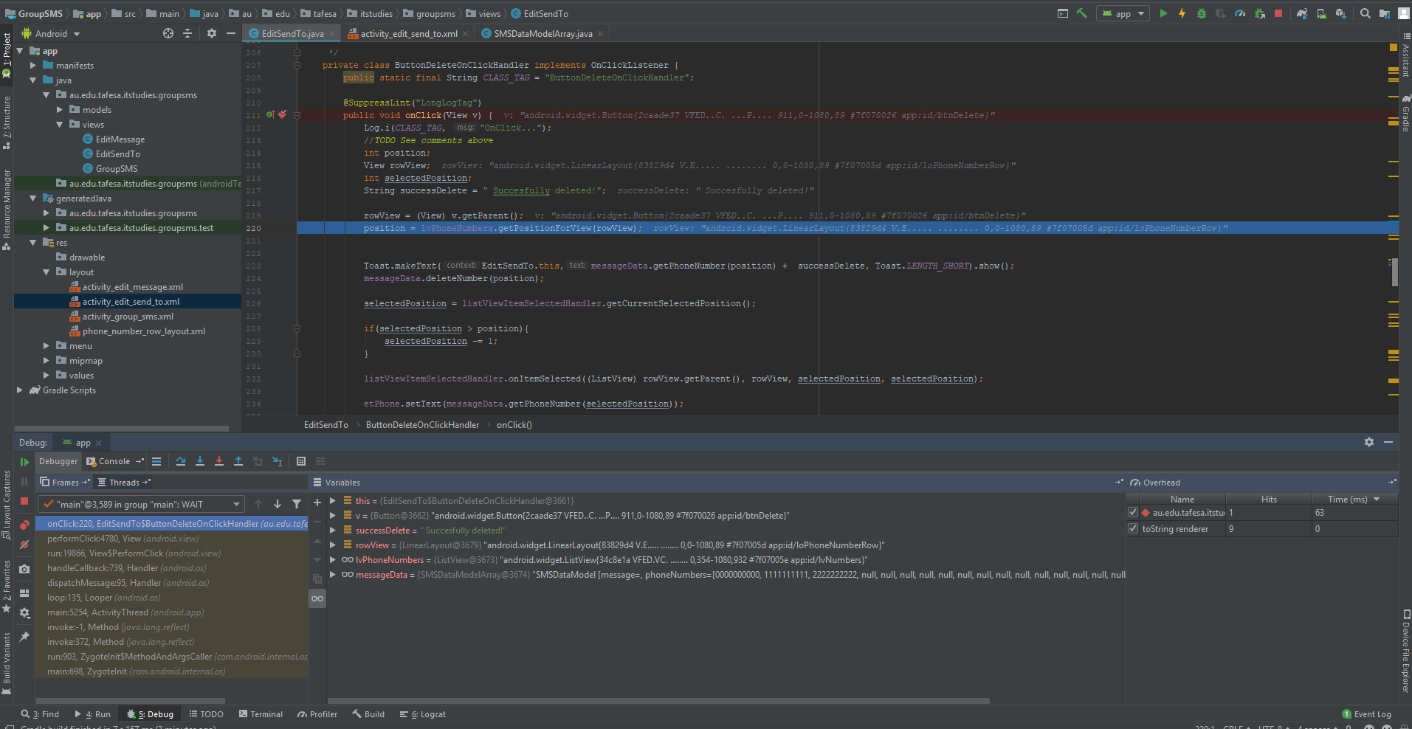

Figure : Get the index of the View where the Delete button was clicked as ‘position’



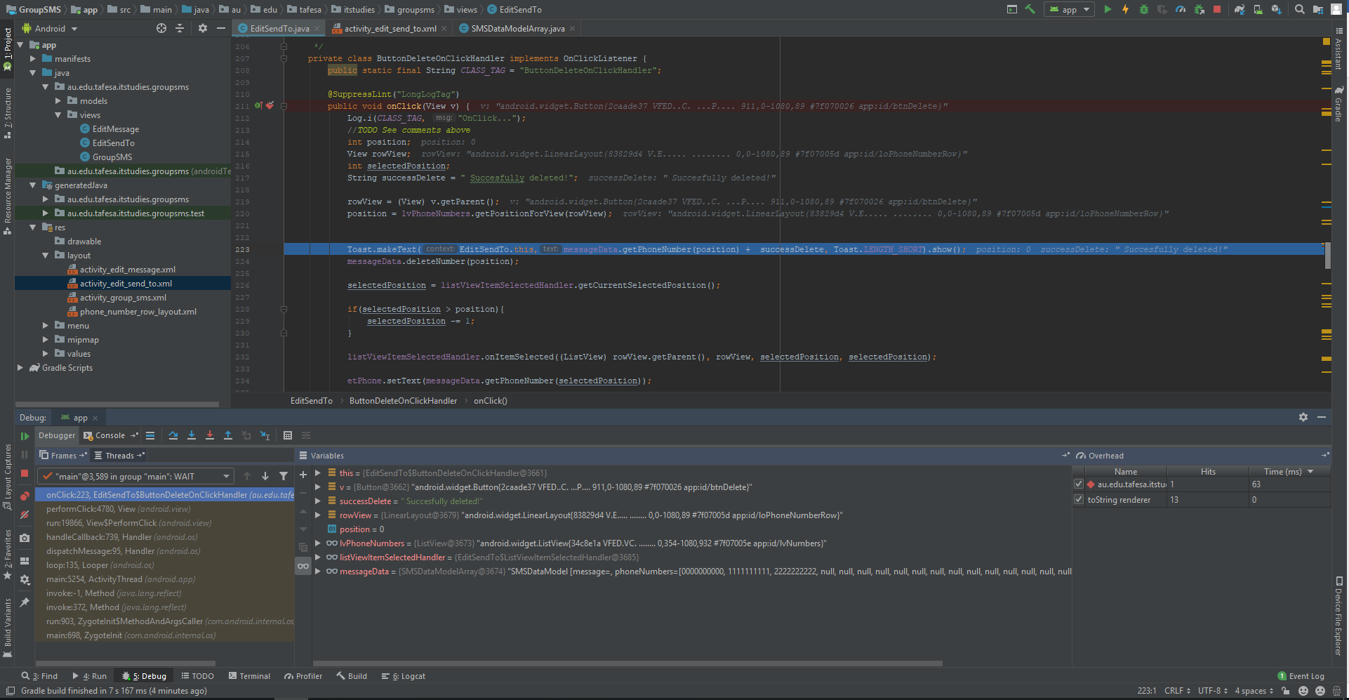

Figure : Output a Toast message



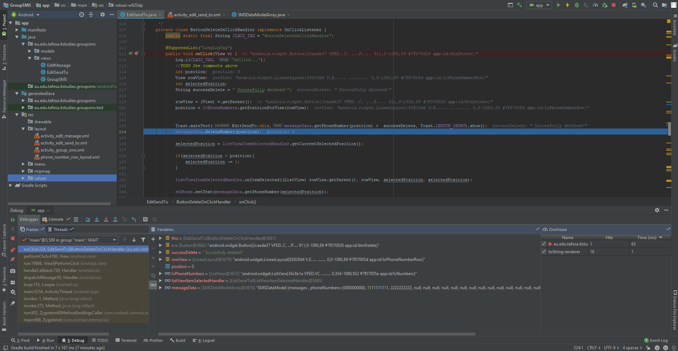

Figure : Delete the number corresponding to the ‘position’ from the array



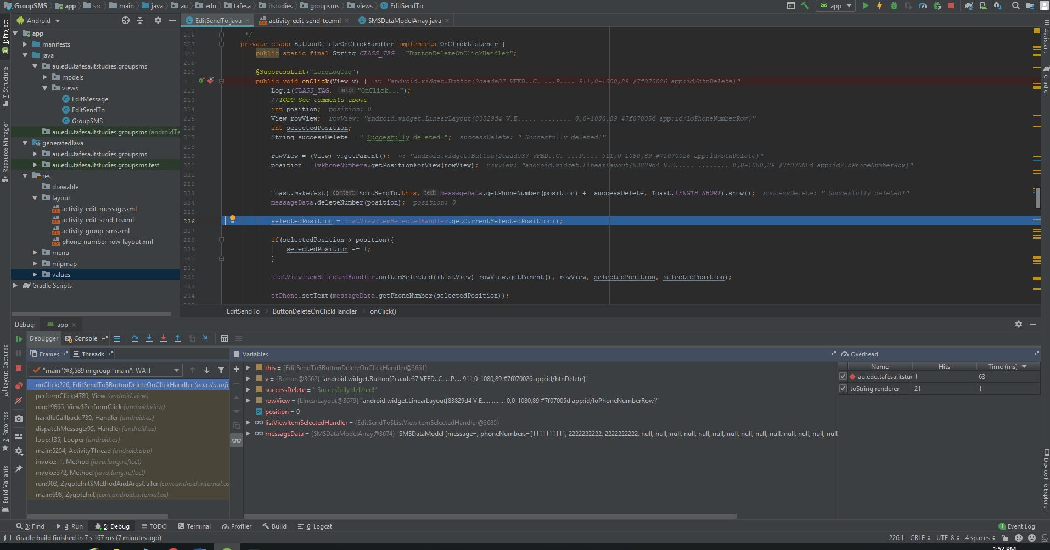

Figure : Get the index of the view currently selected as 'selectedPosition'



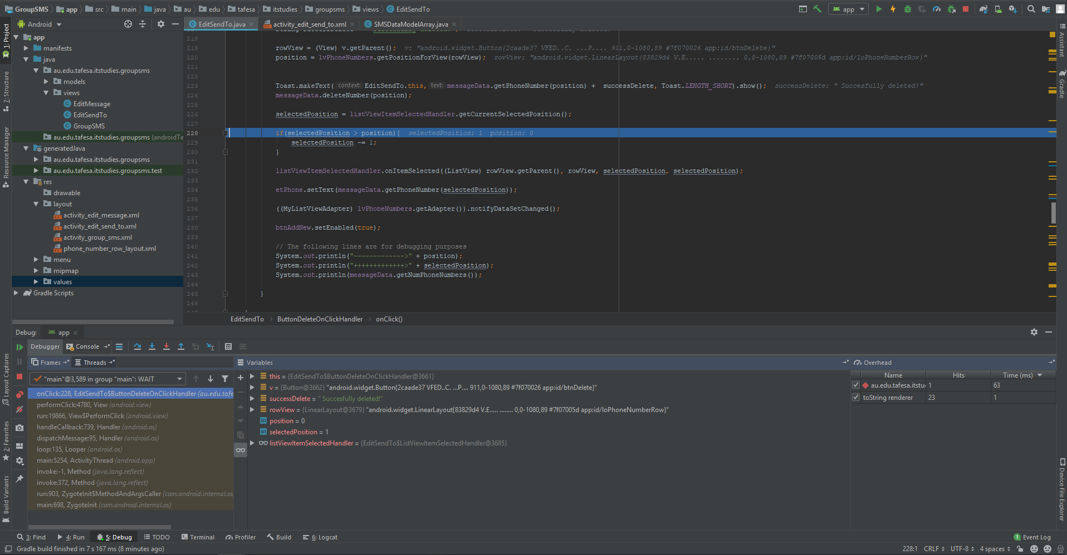

Figure : Check if the 'position' is bigger than the 'selectedPosition'



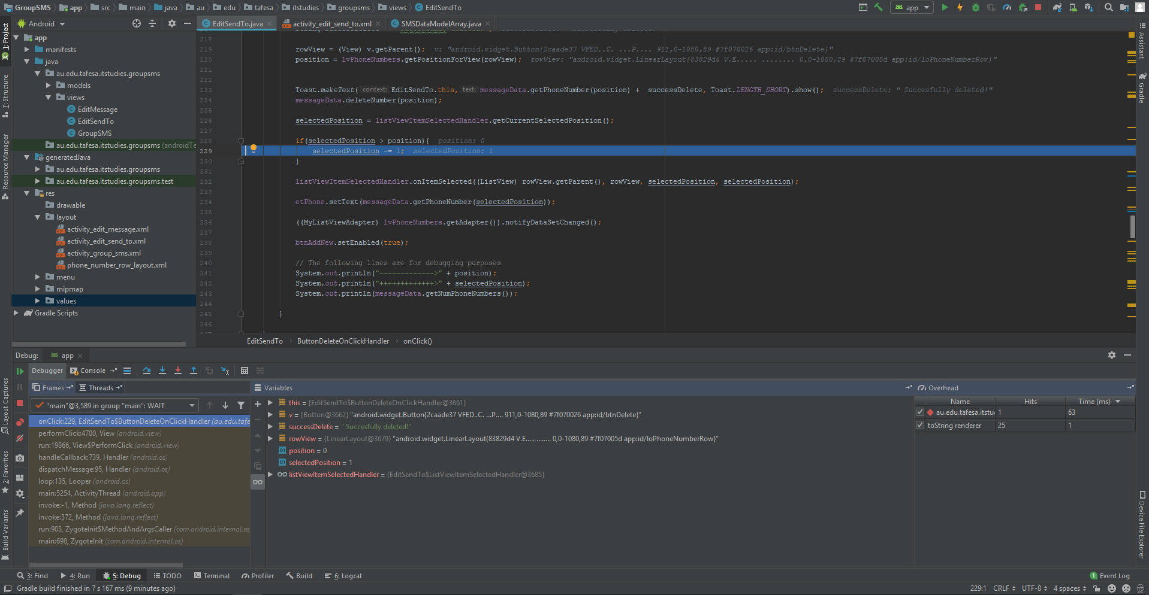

Figure : If is bigger, the selected position get - 1



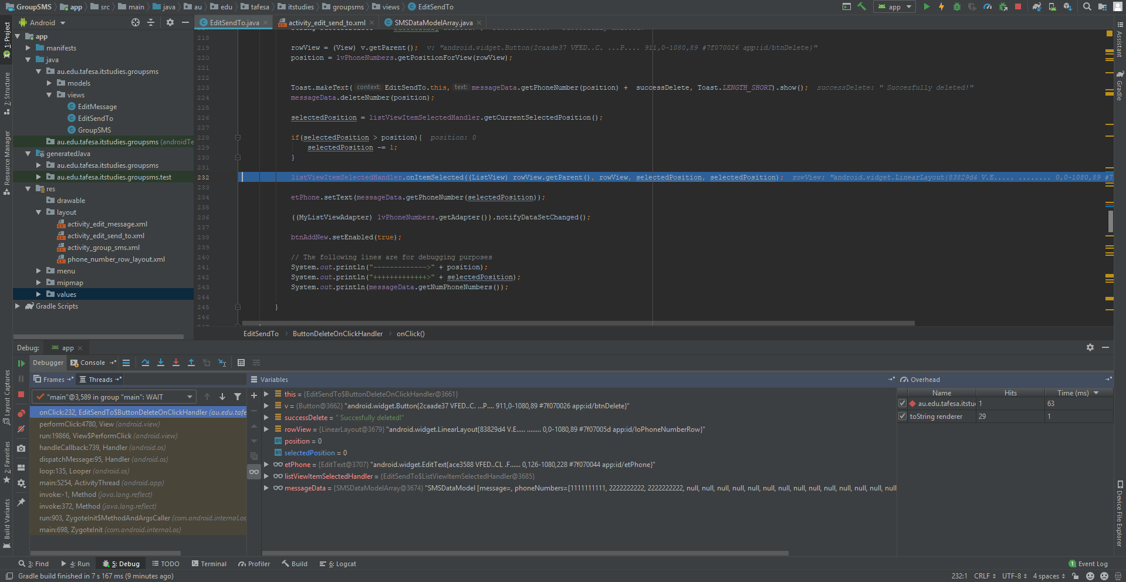

Figure : Notify the parent view of the 'selectedPosition'



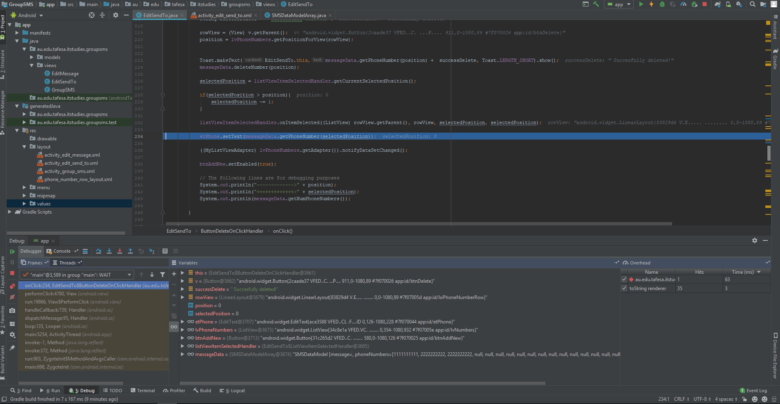

Figure : Set the text in the editor to the number at the 'selectedPosition'



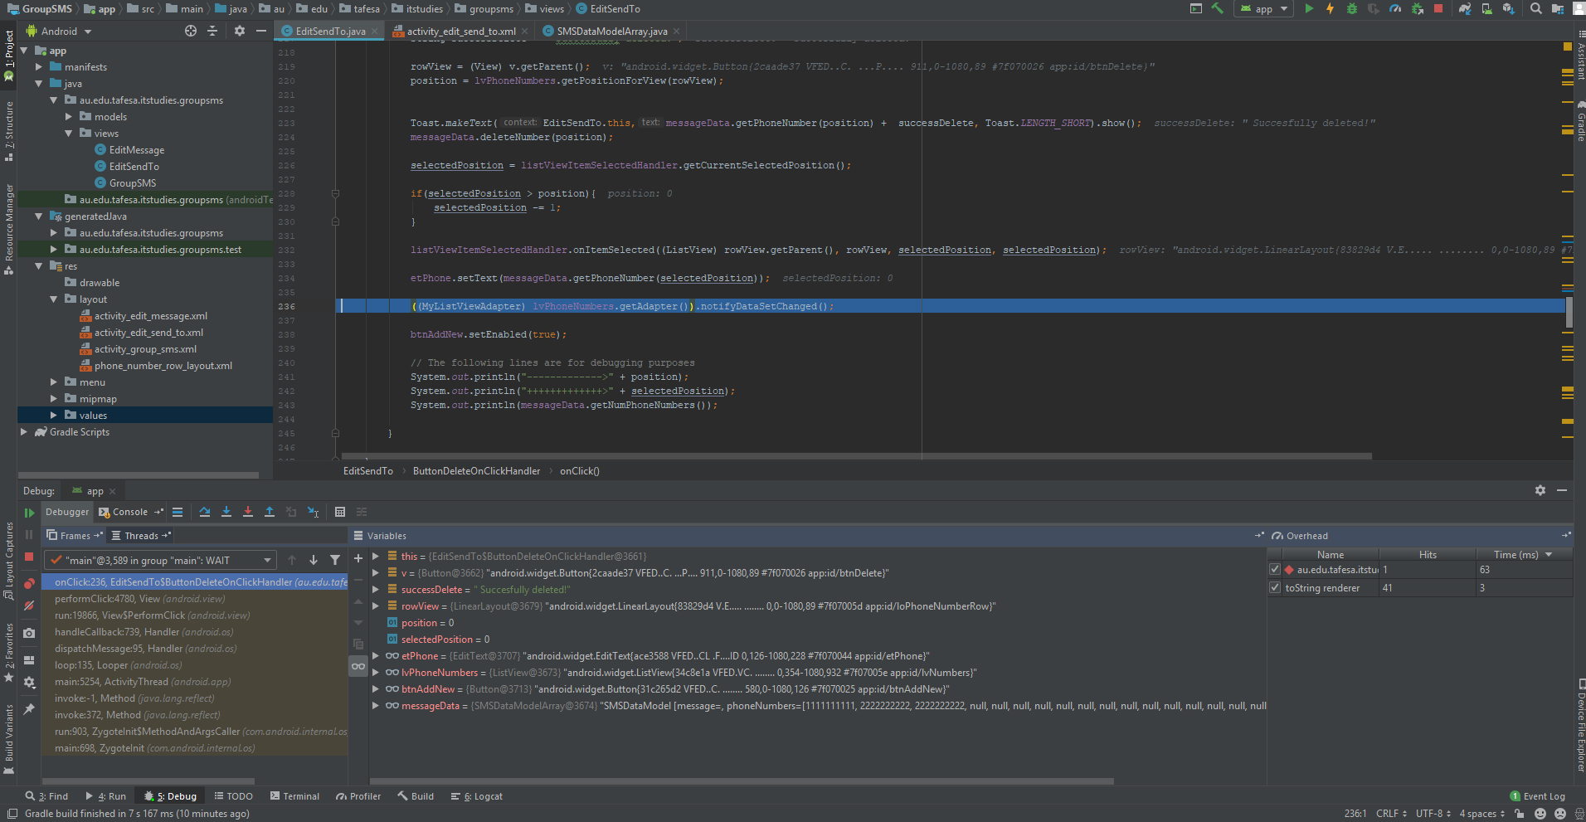

Figure : Notify the ListView of the change in the dataset



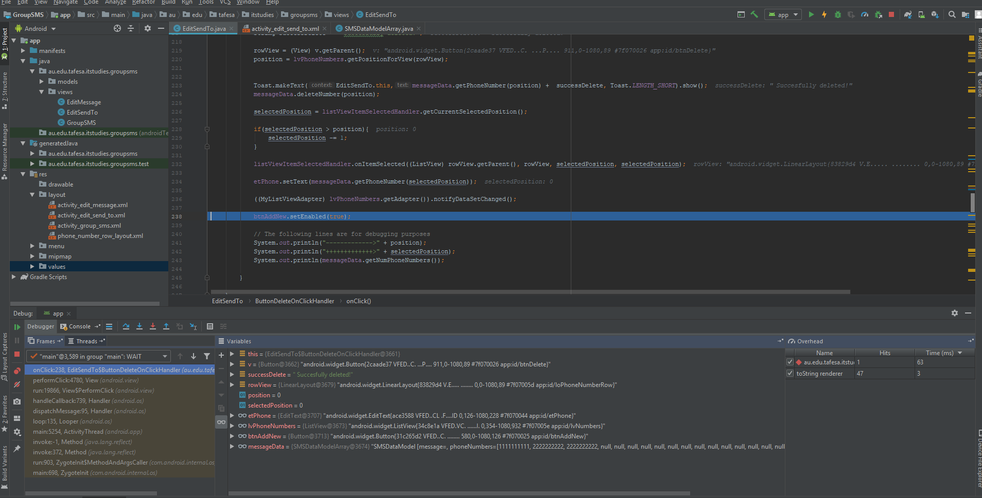

Figure : Enable the 'Add New' button

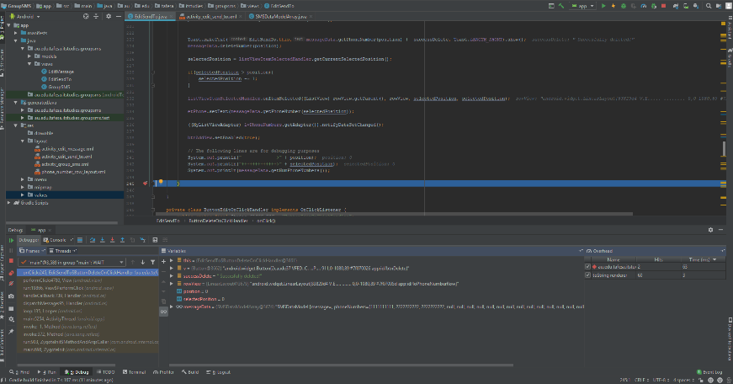 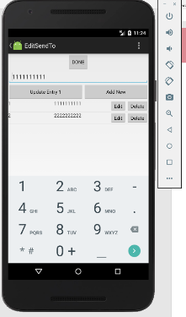

Figure : The method is concluded Figure : End Result